PMR446 TTI TX-1446 Radios – Ordering

Company: Radios-UK

52 Chichester Road,
Tilehurst,
Reading,
RG30 4XB
VAT Number: 537 7472 15

Orders not accepted by phone!

“Call us by phone on 01189421240 Mon-Fri between 9am and 3pm for accounts & billing problems.”

To order:

- Go to website: http://www.radios-uk.com/tx1446.htm
- Click ADD TO CART
- Change QUANTITY to 2
- Select UK DELIVERY for SHIPPING ZONE
- Click RECALCULATE & check costs
- Click GO TO PAYMENTS and complete the payments form

Costs:
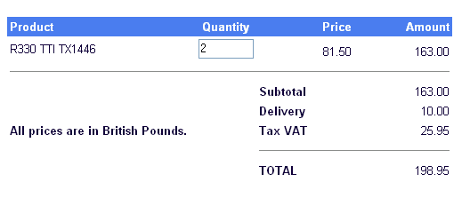

As the school can claim VAT back, the total cost should be £173.00 including delivery.

